-Medical Image Data Analysis Projects Report-

**Another Visualization of ECG Signals**

**In The Time-Frequency Domain**

Kang HanBit

Department of Digital HealthCare, Yonsei University

**Abstracts**

*The Work Presented in this report shows Another type of visualization for ECG(Electrocardiogram)in time-frequency domain (TFD) by Continuous Wavelet Transform(CWT); Scalogram, named “Cardio Petal” because of its similarity to a flower’s petal. In beginning, introduction with a brief overview of the background of ECG analysis and the importance of detecting atrial fibrillation using ECG. Following this, the ECG Dataset is introduced, along with methodologies for identifying R-peaks in ECG analysis. The theory behind the Continuous Wavelet Transform (CWT) and a novel ECG scalogram called ‘Cardio Petal’ is introduced. The results of visualizing ECG data using ‘Cardio Petal’ are presented, with a comparison with the visualization results of other types of time-series data. Finally, the conclusion discusses the potential and suggestions for improvements of ‘Cardio Petal’.*

**Ⅰ. Introduction**

Electrocardiography (ECG) has been a cornerstone in the field of cardiology for over a century, offering a non-invasive yet insightful glimpse into the electrical activity of the heart. This diagnostic tool works by measuring the electrical signals generated by the cardiac muscle during each heartbeat, which are crucial for identifying a range of cardiac abnormalities. Among these, atrial fibrillation (AFib), a common yet serious arrhythmia, stands out due to its prevalence and potential to lead to severe complications such as stroke and heart failure**. (European Heart Rhythm, 2010)**

The detection of atrial fibrillation through ECG analysis is of paramount importance. AFib is characterized by rapid and irregular beating in the heart's upper chambers, which can be identified by specific ECG patterns. These patterns, however, can be subtle and easily missed without careful analysis. The early detection and accurate diagnosis of AFib are critical, as they enable timely intervention, reducing the risk of severe complications and improving patient outcomes.

Advancements in technology and the development of sophisticated ECG interpretation algorithms have significantly enhanced our ability to detect AFib. These innovations are improving the accuracy of diagnoses and making ECG analysis more accessible in various healthcare not only doctor but also normal people with portable medical devices or wearable devices. So, the easier, the more intuitive visualization of ECG to check heart condition is needed. This report suggests the new type of ECG visualization suitable wearable or portable devices.

**Ⅱ. Method**

1. **ECG dataset**

The PhysioNet Computing in Cardiology Challenge 2017(CiCC2017) focused on the classification of AF from short single-lead ECG recordings, a task that poses unique challenges due to the brevity and limited information of such recordings, each lasting from 30 seconds to 60 seconds.**(Clifford et al., 2017)** These recordings were sourced from a variety of patients and included not only AF episodes but also other arrhythmias, normal sinus rhythms and noisy providing a comprehensive dataset for algorithm development and testing.

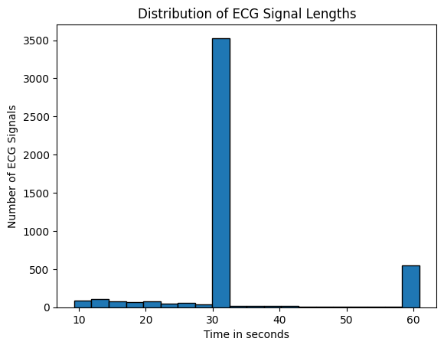

Figure 1 : ECG Record Time Distribution Histogram

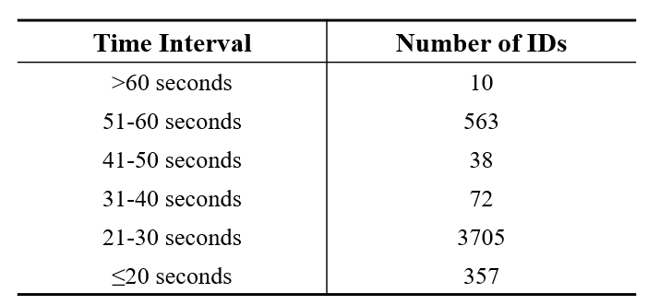

Table 1: Distribution of ECG Recording Duration.

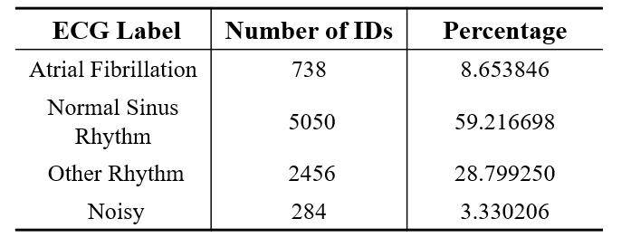

Table 2: Data profile for training set.

With this data, there are lots of algorithms and AI projects. It’s sufficient to evaluate the performance of AFib classification, but too many samples are in this visualization project and the data’s time-label distributions are biased. So this report picks some patients (not all) in each label and finds a difference between them.

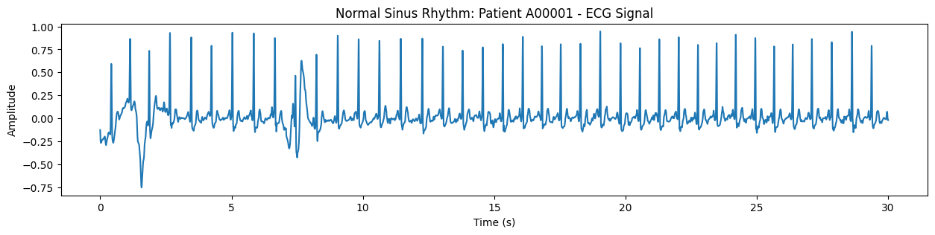

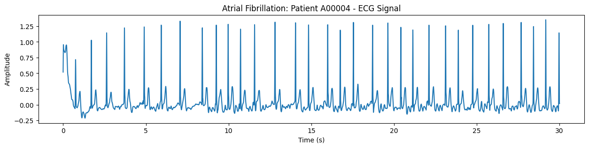

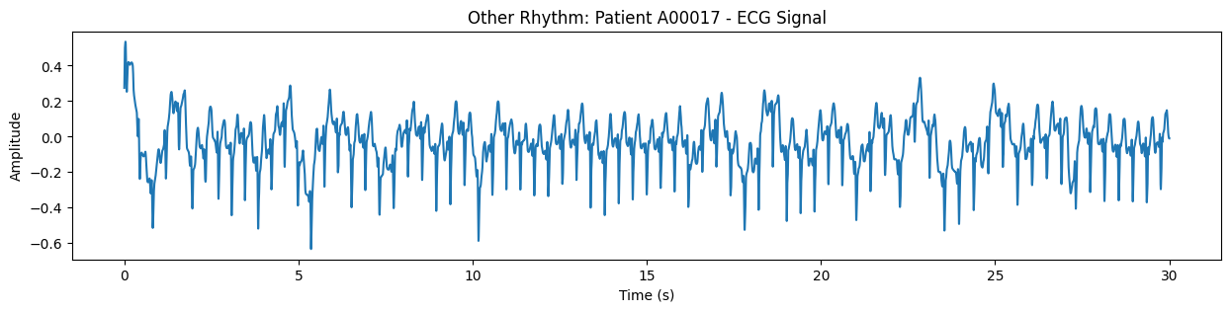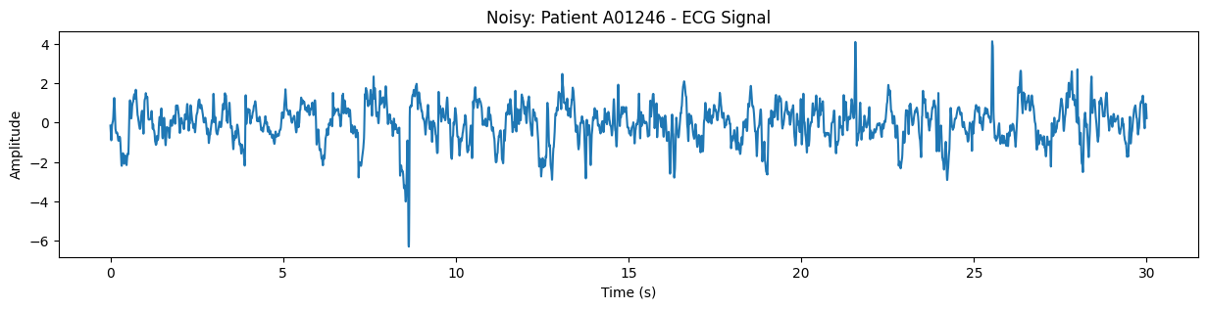

Figure 2 : Examples of ECG waveforms.

These four ECG waveforms refer to the examples in the description of the CICC2017 dataset.

1. **QRS Detection Algorithm**

This Project intends to use the Pan-Tompkins algorithm, the most commonly used method, to denoise and analyze the characteristics of each beat in the waveforms of Fig2 from raw ECG data**(Pan & Tompkins, 1985).**

The Pan-Tompkins algorithm, developed in 1985 by Jiapu Pan and Willis J. Tompkins, is a highly regarded method in electrocardiogram (ECG) signal processing for detecting QRS complexes, which indicate ventricular depolarization in the heart. This algorithm is praised for its robustness and adaptability across different patient conditions, utilizing a series of digital signal processing steps – including bandpass filtering, differentiation, squaring, and moving-window integration – to enhance QRS features while suppressing noise. Its adaptive thresholding mechanism adjusts to varying ECG signal characteristics, making it effective in diverse clinical scenarios and a foundational technique in cardiac monitoring and analysis.

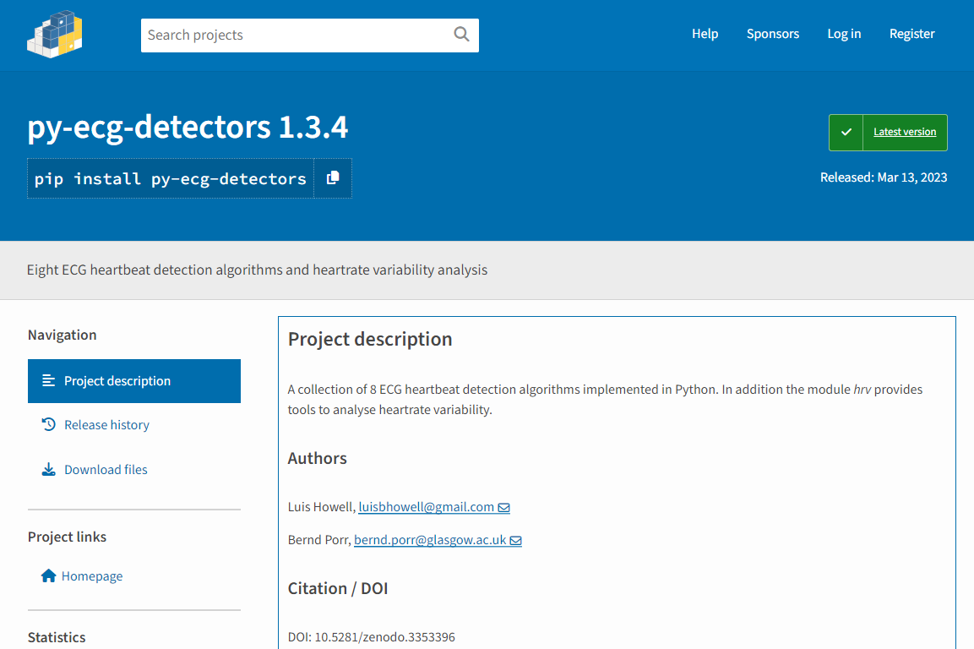

Figure 3 : py-ecg-dectors website instruction.

Python module suggests ECG analysis tools with Pan-Tompkins like Fig3. With this module, Finding r-peaks by the PT algorithm shows the QRS complex information on ECG which means It can analyze not only all sample range of ECG but in segmented beat range.

1. **CWT-Continuous Wavelet Transform**

To analysis in Time-Frequency domain, the main components of this project is ‘Continuous Wavelet Transform’ (CWT). Not in Sound wave, ECG signals are utilized in Classification for Heart disease and Signal Reconstruction **(Mashrur et al., 2021)**. CWT is defined as follow:

$$X_{ψ}^{ϕ}\left(s,τ\right)=\left\langle ϕ,ψ_{s,τ}\right\rangle =\frac{1}{\sqrt{s}}\int_{-∞}^{∞}{ϕ\left(t\right)}⋅ψ^{*}\left(\frac{t-τ}{s}\right) dt$$

The Continuous Wavelet Transform (CWT) is utilized in ECG signal analysis to detect brief and abrupt changes in frequency that are characteristic of Atrial Fibrillation (AFib). This condition presents unique challenges that are difficult to address with standard fixed-window spectrogram analysis. By convolving the ECG signal epoch (ϕ) with a scaled and translated mother wavelet (ψs,τ), where τ shifts the wavelet in time and s adjusts the scale for frequency resolution, the CWT calculates wavelet coefficients (Xψϕ). The absolute values of these coefficients provide a detailed power distribution across frequencies and times in the form of a scalogram. This time-scale depiction facilitates a nuanced multi-resolution analysis, capturing the quick and intricate frequency shifts associated with the erratic heart rhythms of AFib.

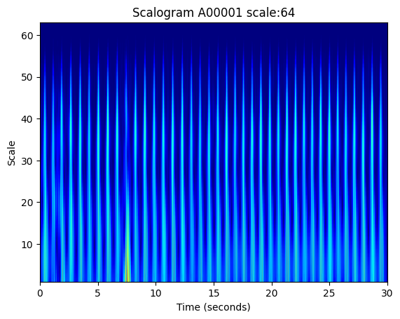

Figure 4 : Using ‘pywt’ module for Normal Sinus Rhythm in scale 64.

In scalogram, the Morlet wavelet, introduced by the geophysicist Jean Morlet, is used. It is a complex wavelet used in continuous wavelet transforms for time-frequency analysis, particularly favored for its excellent localization in both time and frequency domains. Characterized by a Gaussian envelope modulated by a cosine function, it offers a balance between temporal and frequency resolution, allowing for precise detection of signal features at specific frequencies and times. In previous study, using Morlet -based feature extraction method is applied to actual mechanical signals to detect and diagnose faults.**(Lin & Qu, 2000)** Its adjustable parameters make it highly adaptable for various signal processing applications, including the analysis of intricate signals such as those in cardiology for Atrial Fibrillation detection, geophysical data interpretation, and brain wave analysis in EEG studies. The Morlet wavelet's harmonic properties, due to the smooth frequency response of the Gaussian-cosine combination, make it a preferred choice forapplications requiring detailed frequency selectivity andtemporal precision.

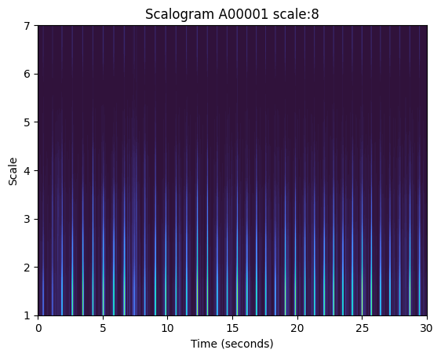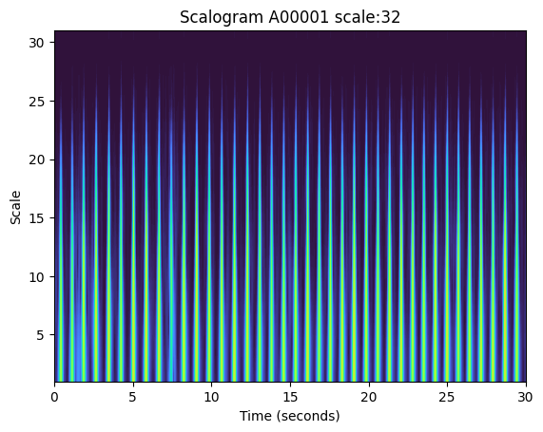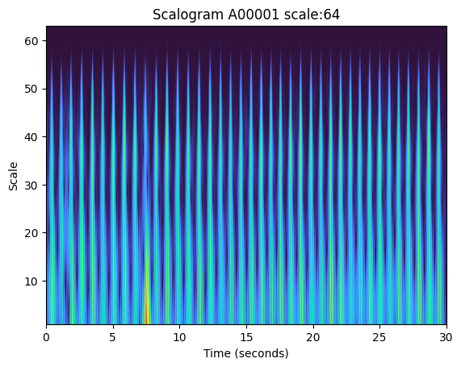

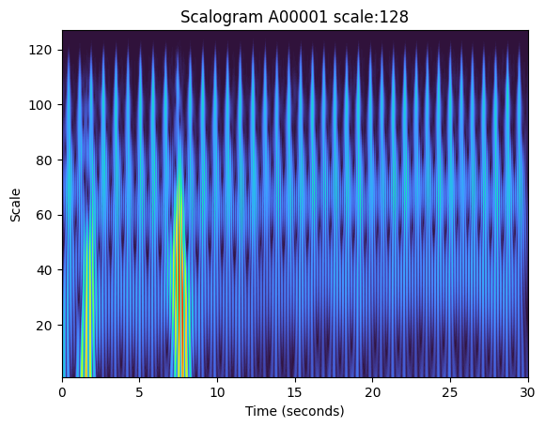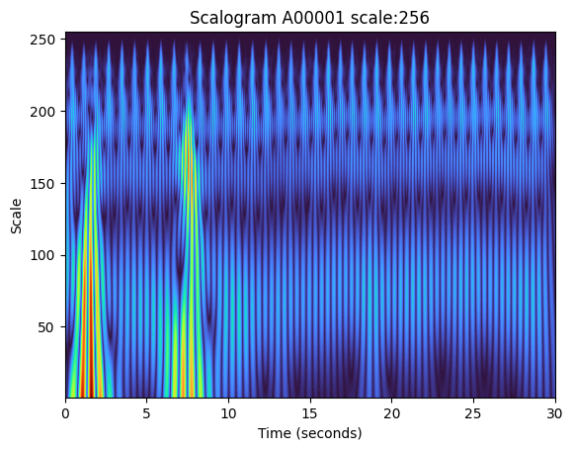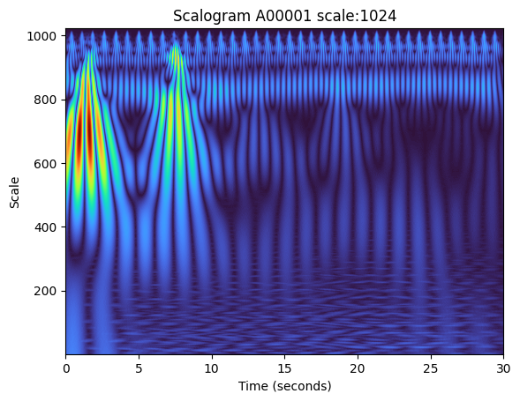

Figure 5 : Examples of Normal ECG Scalogram in different scale range

Fig 5 shows Scales which mean the width of amplitude wavelet scaled amplitude are difference in multiple of 2. There are dynamic changes in 64 and 256. Scale 64 shows, at first, a frequency effects in scalogram. Scale 256 shows morphological changes in scalogram.

1. **Cardio Petal**

This a new Scalogram visualization refers to Polar Spectrum visualization named ‘Irisgram’. **(Zhivomirov)**

Irisgram’s polar method is Converging Time and frequency scales in Theta(𝜃) Rho(𝜌) method. Fig 6 Image is principle of Polar coordinate from Irisgram paper**. More specific information and Matlab code were received**.

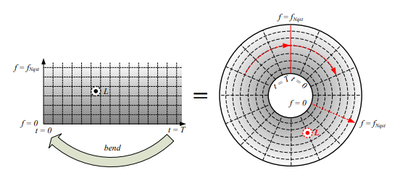

Figure 6 : Principle Image of Polar Coordinate in Time-Frequency domain from **Irisgram paper**.

𝜃={−𝜋:2𝜋𝑇−1:𝜋}, 𝑤ℎ𝑒𝑟𝑒 𝑇 𝑖𝑠 𝑡ℎ𝑒 𝑙𝑒𝑛𝑔𝑡ℎ 𝑜𝑓 𝑡𝑖𝑚𝑒 𝑣𝑒𝑐𝑡𝑜𝑟.

𝜌=max(𝑓)3+𝑓, 𝑤ℎ𝑒𝑟𝑒 𝑓 𝑖𝑠 𝑡ℎ𝑒 𝑓𝑟𝑒𝑞𝑢𝑒𝑛𝑐𝑦 𝑣𝑒𝑐𝑡𝑜𝑟.

𝑋= 𝜌×cos𝜃, 𝑎𝑛𝑑 𝑌=𝜌×sin𝜃.

The new visualization of Scalogram of ECG uses this coordinate method. But different to original method, this new visualization 𝜌 = max(scale), 𝜃 is same parameter with original method.

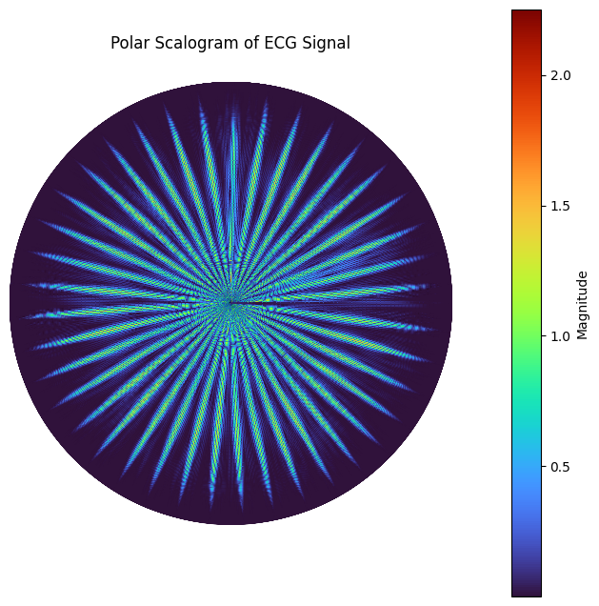

Figure 7 : A Cardio Petal of Normal Sinus Rythm

Fig 7 is the Polar scalogram of all time ECG signal by new method. The Image seems like follower’s petal so this visualization would name ‘Cardio Petal’.

**Ⅲ**. **Result**

All ECG signals to Cardio Petal is difficult to diagnose AFib and Normal. But Other rhythm is easily find different point with Normal rhythm image.

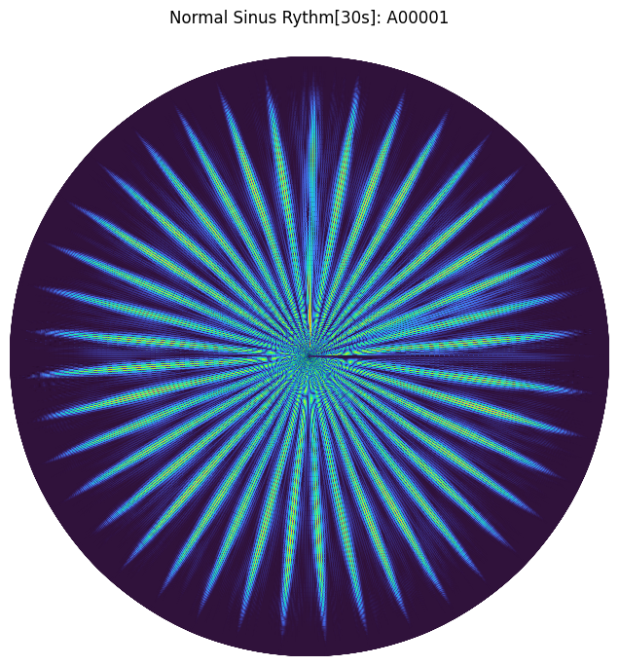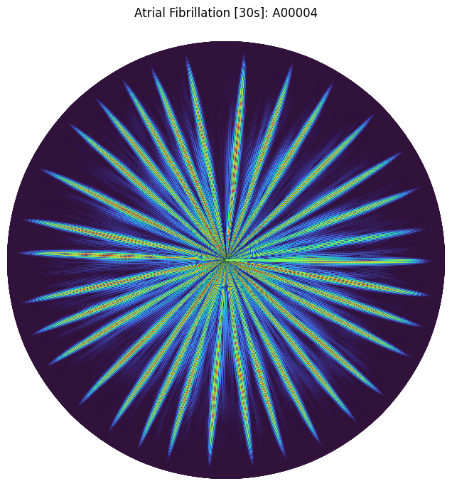

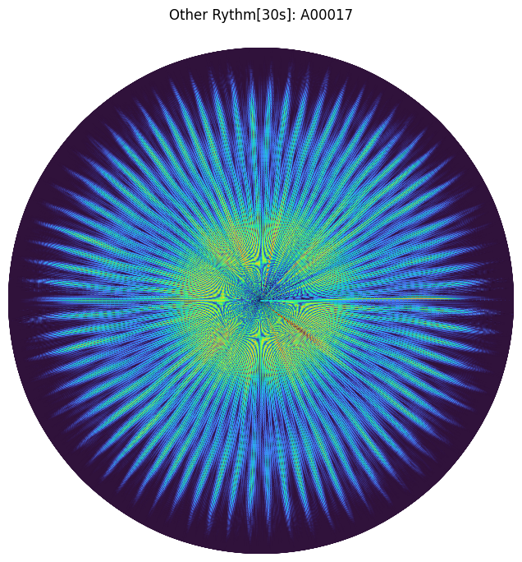 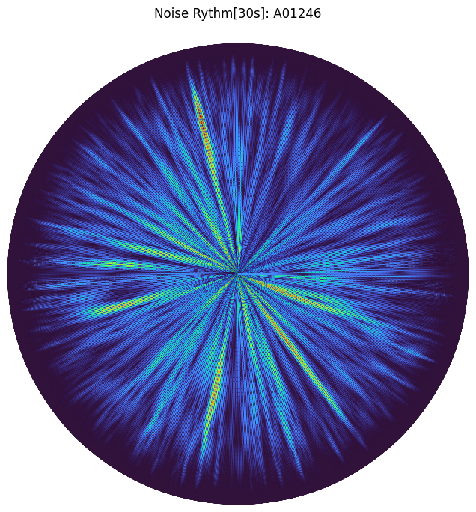

Figure 8 : A Cardio Petal in 30s Images examples: Normal Sinus Rhythm(1), AFib(2), Other Rhythm(3), Noise Rhythm(4)

To Find solution in diagnosing AFib, Using Pan-Tompkins Algorithm for Segmentation QRS complex (1 heart beats) is used. At first, Find R-peaks by Pan-Tompkins and segment ECG signal with R-peaks index data.

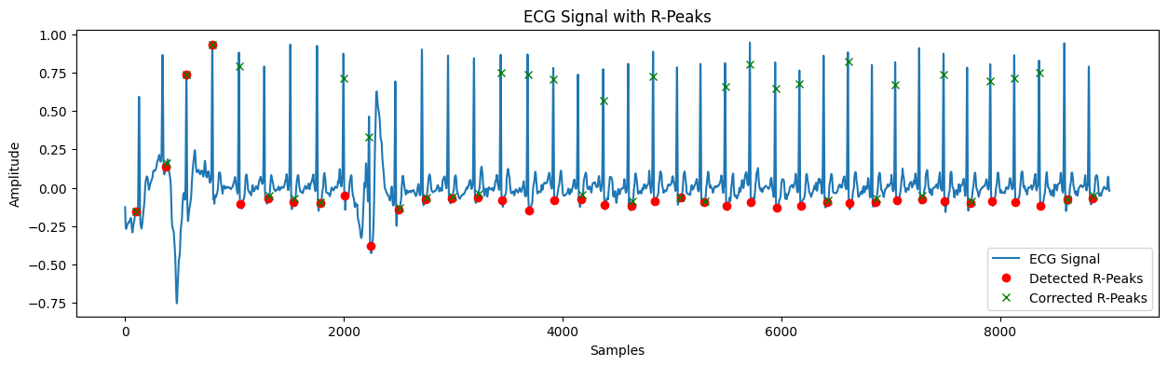

Figure 9 : R-peaks detection by py-ecg-dector’s PT algorithm with corrected R-peaks.

Some errors in the R-peak detection have been corrected, however, due to a module error, there are false positive peak marks. But in segmentation with false positive peaks, the segment would include real peaks. Because the distance between error and real peaks is not extremely long. So Fig 10 shows the segmented Cardio Petal Image.

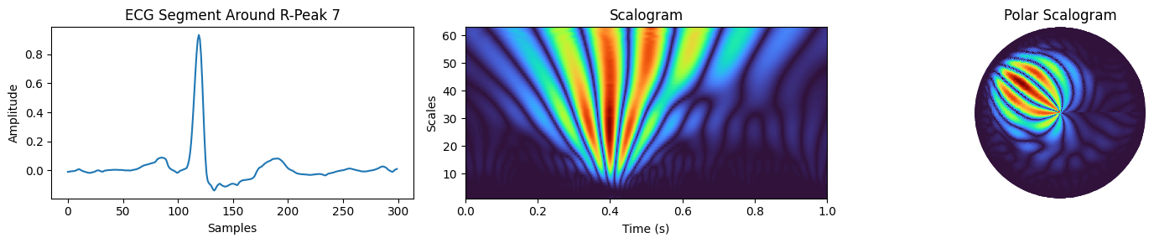

Figure 10 : Segmented 1 Sample of QRS complex Cardio Petal.

In this visualization experiments, two visualization features will be introduced:

* + 1. **Plot Cardio Petal (1 QRS)**

By visualizing the cardio petal on a 1-beat basis, we aim to analyze the information contained within each individual petal.

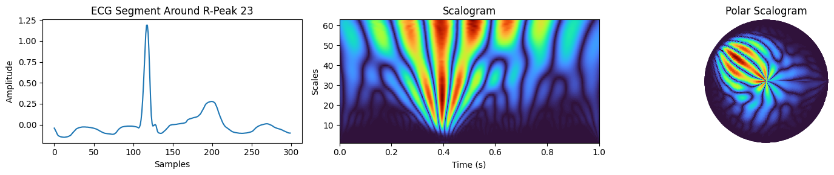



Figure 11: Segmented one AFib Sample of QRS complex Cardio Petal. Normal Sinus Rhythm (Left), AFib (Right).

In the one Cardio Petal, the radial axis represents the scales of the wavelet transform (which correlate to frequency), and the angular axis represents time. Brighter colors typically indicate higher power or energy at a particular scale and time. Here are some observations based on the comparison:

|  |  |
| --- | --- |
| **Atrial Fibrillation (AFib)** | * The patterns appear more complex and less coherent, which may reflect the irregular and rapid electrical impulses characteristic of AFib. * There is a mixture of colors without a clear, consistent pattern, suggesting a wide range of frequencies and rapid changes in the heart's electrical activity. * The lack of clear and regular "spokes" or lines radiating from the center might be indicative of the absence of regular R-peaks, as AFib often results in an irregular heartbeat. |
| **Normal Sinus Rhythm** | * The pattern is more orderly and structured, with clear and consistent radial lines. These lines represent regular R-peaks in the ECG signal, which are typical of a normal heart rhythm. * The uniformity of the radial lines suggests a consistent heart rate and rhythm, with each heartbeat following a regular pattern. * The presence of fewer frequencies, as indicated by the concentration of energy at specific scales (radii), is consistent with the normal rhythmic activity of the heart. |

Table 3: Difference between Normal and AFib Cardio Petals.

Comparing the two, the polar scalogram for AFib shows a disorganized pattern, while the normal rhythm shows a structured pattern with clear, regular features. This reflects the underlying physiological differences between the chaotic electrical activity in AFib and the coordinated electrical activity in a normal heart rhythm.

**2)Plot cardio petals (3-Heartbeats)**

When the time range was manually set to draw the Cardio Petal, visualizing a sample size of 600 samples, which is twice the fundamental frequency (Nyquist), resulted in seeing various appearances of the Cardio Petal with at least 2-3 peaks.

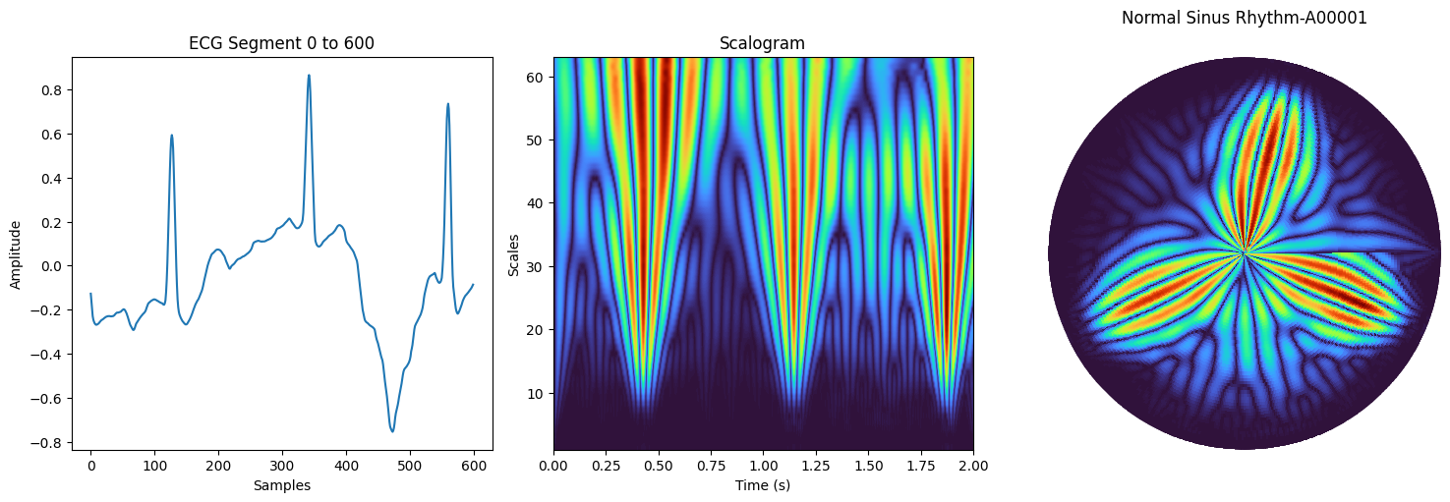 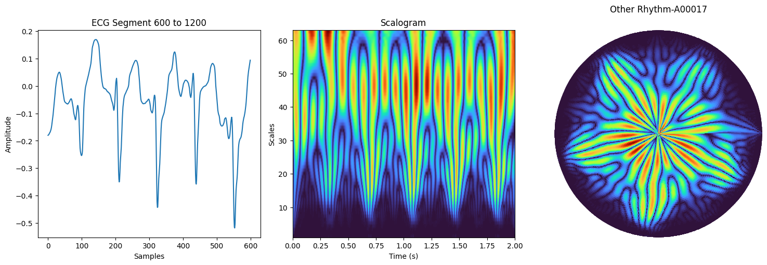

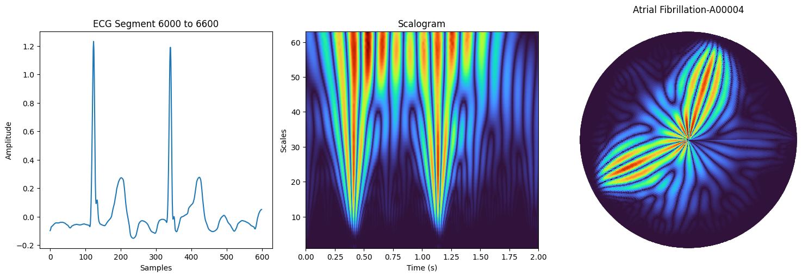 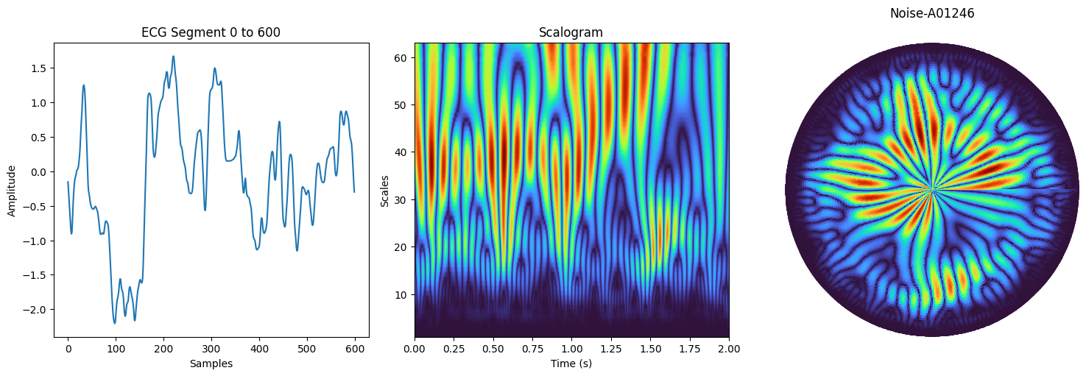

Figure12: Difference type of Cardio Petal in 600 samples

**Ⅳ. Conclusion**

In conclusion, the innovative "Cardio Petal" visualization, employing the Continuous Wavelet Transform for ECG analysis, revolutionizes cardiac data representation by intuitively combining time-frequency domain information. Its primary strength lies in its intuitive pattern recognition, enabling clear identification of complex cardiac rhythms like atrial fibrillation, thus aiding healthcare professionals in quickly discerning changes in cardiac electrical activity. Additionally, its multi-dimensional portrayal of data offers a comprehensive understanding of cardiac rhythms, enhancing both diagnostic capabilities and educational value.

Significantly, the aesthetic and educational appeal of this visualization method makes it not only an effective tool for medical professionals but also a potential asset in wearable devices. Its intuitive nature could allow even non-experts to assess the severity of cardiac conditions, making it a valuable addition to consumer health technology. However, the technique does require expert interpretation, which might limit its use among laypersons. Furthermore, the time and computation required to generate and interpret Polar Scalograms make real-time analysis challenging, suggesting a need for further development for effective use in immediate diagnosis or continuous monitoring.

By expanding the "Cardio Petal" approach to integrate with wearable technology and enhancing its user-friendliness, its application can extend beyond clinical settings to daily health monitoring, potentially transforming cardiac care and patient engagement in their own health management. The continued refinement and exploration of this technique will be crucial for its widespread adoption and effectiveness in various healthcare and educational environments.

**Reference**

1. European Heart Rhythm, A., European Association for Cardio-Thoracic, S., Camm, A. J., Kirchhof, P., Lip, G. Y., Schotten, U., Savelieva, I., Ernst, S., Van Gelder, I. C., Al-Attar, N., Hindricks, G., Prendergast, B., Heidbuchel, H., Alfieri, O., Angelini, A., Atar, D., Colonna, P., De Caterina, R., De Sutter, J., . . . Rutten, F. H. (2010). Guidelines for the management of atrial fibrillation: the Task Force for the Management of Atrial Fibrillation of the European Society of Cardiology (ESC). *Eur Heart J*, *31*(19), 2369-2429. <https://doi.org/10.1093/eurheartj/ehq278>

2. Clifford, G. D., Liu, C., Moody, B., Lehman, L. H., Silva, I., Li, Q., Johnson, A. E., & Mark, R. G. (2017). AF Classification from a Short Single Lead ECG Recording: the PhysioNet/Computing in Cardiology Challenge 2017. *Comput Cardiol (2010)*, *44*. <https://doi.org/10.22489/CinC.2017.065-469>

3. Pan, J., & Tompkins, W. J. (1985). A Real-Time QRS Detection Algorithm. *IEEE Transactions on Biomedical Engineering*, *BME-32*(3), 230-236. <https://doi.org/10.1109/TBME.1985.325532>

4. Lin, J., & Qu, L. (2000). Feature Extraction Based on Morlet Wavelet and Its Application for Mechanical Fault Diagnosis. *Journal of Sound and Vibration*, *234*(1), 135-148. <https://doi.org/10.1006/jsvi.2000.2864>

5. Mashrur, F. R., Islam, M. S., Saha, D. K., Islam, S. M. R., & Moni, M. A. (2021). SCNN: Scalogram-based convolutional neural network to detect obstructive sleep apnea using single-lead electrocardiogram signals. *Comput Biol Med*, *134*, 104532. <https://doi.org/10.1016/j.compbiomed.2021.104532>

6. Zhivomirov, H. (2018). A novel visual representation of the signals in the time-frequency domain. *UPB Sci. Bull. Ser. C Electr. Eng. Comput. Sci*, *80*, 75-84.

7. "Spectrogram Visualization with Matlab." Spectrogram Visualization with Matlab – File Exchange – MATLAB Central. Available online: www.mathworks.com/matlabcentral/fileexchange/64882-spectrogram-visualization-with-matlab (accessed on 23 December 2023).

8. Zyout, A., Alquran, H., Mustafa, W. A., & Alqudah, A. M. (2023). Advanced Time-Frequency Methods for ECG Waves Recognition. *Diagnostics (Basel)*, *13*(2). <https://doi.org/10.3390/diagnostics13020308>